

##### Question/Answer Booklet

Name:

Yr 11 ATAR PHYSICAL EDUCATION STUDIES

Exercise Physiology Class Test 2021

**Time allowed for this paper**

Working time for paper: 45 minutes

**Material required/recommended for this paper**

*To be provided by the supervisor*

This Question/Answer Booklet

|  |  |  |  |
| --- | --- | --- | --- |
| **Contents:**  Exercise Physiology | Multiple choice  Short answers  Extended questions | 10 marks  40 marks  10 marks  **Total marks** | **/60** |

**Circle the correct letter/answer:**

**Multiple Choice (10 marks)**

1. 45 seconds into a 1500m run, which energy system would be providing the highest proportion of energy for ATP production?

(a) ATP-CP

(b) Lactic Acid

(c) Aerobic

(d) Anaerobic

2. An increase in cardiac output is a direct response of the increase in both:

(a) blood pressure and tidal volume

(b) blood pressure and stroke volume

(c) heart rate and tidal volume

(d) heart rate and stroke volume

3. An elite junior basketball player wanting to improve their vertical leap and rebounding ability would be best advised to undertake:

(a) fartlek training

(b) continuous training

(c) interval training

(d) plyometric training

4. Rate of perceived exertion, percentage of heart rate maximum and percentage of VO2 maximum are all valid measures for which principle of training?

(a) specificity

(b) intensity

(c) duration

(d) progressive overload

5. After completing a battery of fitness tests, an athlete was able to identify his strengths and weaknesses in the table below.

|  |  |
| --- | --- |
| **Strengths** | **Weaknesses** |
| * Agility * Balance * Reaction time | * Muscular strength * Power * Speed * Cardiorespiratory endurance |

Based on the results in the table above, the athlete is most likely a:

(a) long distance runner

(b) mixed martial artist

(c) surfer

(d) shot putter

6. Which of the following is **not** a long-term adaptation to physical activity?

1. Decrease in resting heart rate.
2. Decrease in stroke volume at rest.
3. Decrease in cardiac output at rest.
4. Increase in blood volume at rest.

7. The primary energy system used during a javelin throw is:

1. Aerobic energy system.
2. Lactic acid energy system.
3. Anaerobic glycolysis energy system.
4. ATP-CP energy system.

8. In their first session, a personal trainer asks their client to perform as many push ups as possible in one minute. This test is designed to primarily measure the client’s:

1. Muscular strength.
2. Cardiorespiratory endurance.
3. Power.
4. Muscular endurance.

9. The athletes in the picture below are participating in which type of training?

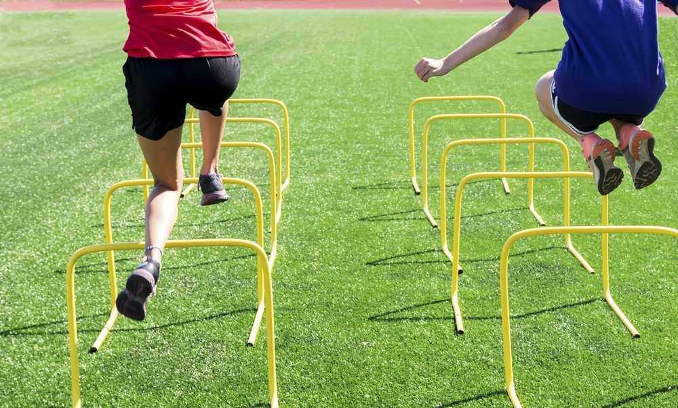

1. Flexibility training.
2. Plyometric training.
3. Fartlek training.
4. Interval training.

10. “If you don’t use it, you lose it” best describes which training principle?

1. Intensity.
2. Specificity.
3. Progressive overload.
4. Reversibility.

**Short Answer (40 marks)**

**Question 11 (9 marks)**

Below is Simon’s regular training program that he has been undertaking for the past six months.

|  |  |  |  |  |  |  |
| --- | --- | --- | --- | --- | --- | --- |
| **Monday** | **Tuesday** | **Wednesday** | **Thursday** | **Friday** | **Saturday** | **Sunday** |
| 5km jog | 1 hour yoga session | Rest day | Swimming  (20 x 50m sprints with 1 min rest) | Rest day | Rest day | Rest day |

In the table below:

1. Identify the training types that are evident in Simon’s exercise program.

(3 marks)

(b) Identify the fitness component relevant to each training type in Simon’s exercise program.

|  |  |  |  |
| --- | --- | --- | --- |
|  | **Monday** | **Tuesday** | **Thursday** |
| **Training type** |  |  |  |
| **Fitness component** |  |  |  |

(3 marks)

(c) Simon is training to compete in a community 5km fun run in six months. Explain why the program is inadequate in terms of three principles of training that have **not** been correctly applied. (3 marks)

|  |
| --- |
|  |
|  |
|  |
|  |
|  |
|  |

**Question 12 (6 marks)**

Josie is a goal keeper for her soccer team in a competition on Saturday mornings. The table below details her diet in the lead up to her game, during and post-event.

|  |  |
| --- | --- |
| **Friday night** | Spaghetti Bolognese  Banana and custard |
| **Breakfast**  **(2 hours before game)** | 1 piece of toast with peanut butter  1 x 250mL chocolate milk  1 x 250mL water |
| **Before game**  **(15 mins before)** | 1 x muesli bar  250mL water |
| **During game** | 500mL water  2 x lollies (snakes) |
| **Lunch**  **(30 minutes after game)** | 250mL water  1 banana  1 x large hot chips |

Suggest three improvements that Josie could make to her diet, providing reasons for your choices. (6 marks)

|  |
| --- |
|  |
|  |
|  |
|  |
|  |
|  |
|  |
|  |
|  |
|  |
|  |

**Question 13 (2 marks)**

In preparing the tournament matches, tennis players have to consider their nutrition prior to matches to maximise their performance and prevent early onset of fatigue.

Explain the difference between high and low GI carbohydrates including when a player is most likely to consume them **prior** to competing in a match.

|  |
| --- |
|  |
|  |
|  |
|  |

**Question 14 (9 marks)**

The graph below displays the interplay of the three energy systems that provide ATP for a runner at the start of their race.

(a) Label the three curves in the boxes provided, identifying each energy system.

(3 marks)

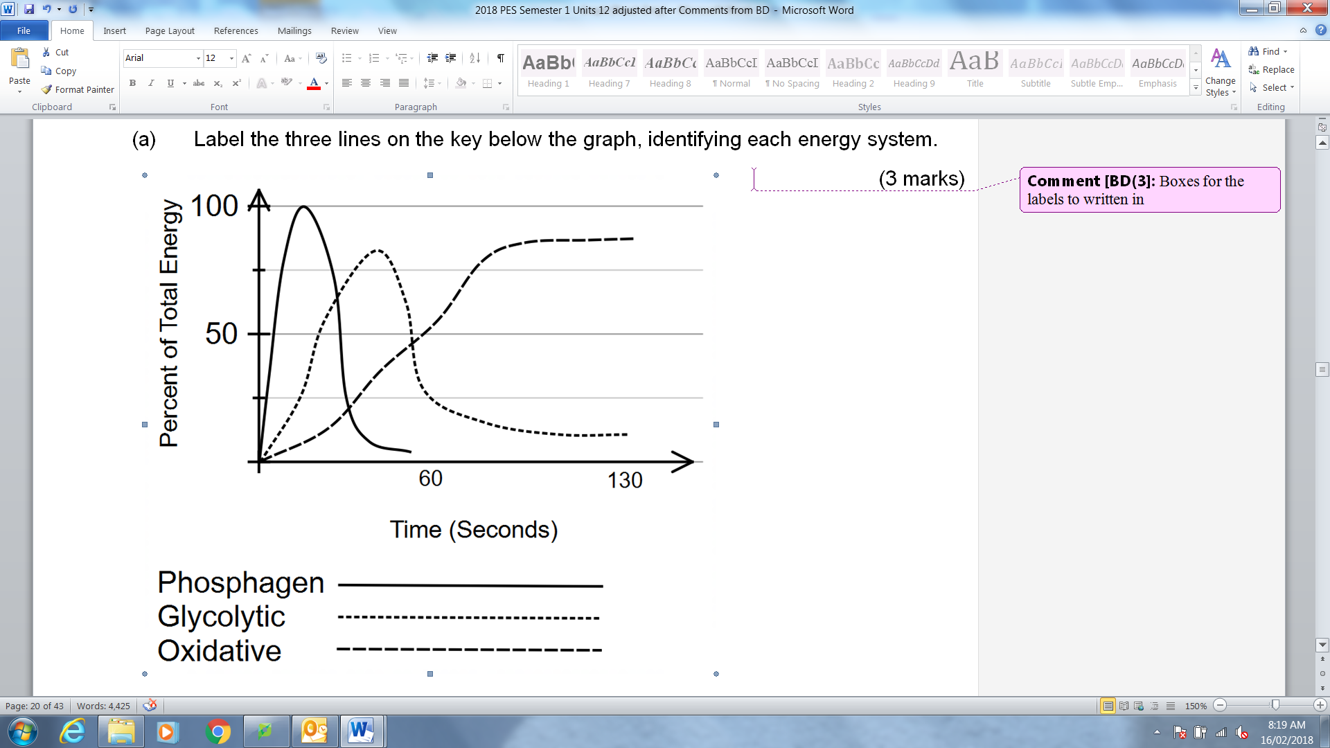

Referring to the graph in part (a)Explain the energy system continuum and outline the timings of each of the energy systems as well as main fuel source for each?

(b) (6 marks)

|  |
| --- |
|  |
|  |
|  |
|  |
|  |
|  |

**Question 15 (6 marks)** In order to improve her strength, power and overall performance in long jump, Tiffany has undertaken a training program that requires her to perform exercises like squats, lunges, bicep curls and bench press using heavy weights. She generally performs three sets of ten reps of each exercise.

(a) Identify the type of training Tiffany is utilising.

___________________________ (1 mark)

(b) Tiffany’s training program incorporates exercises that cause her muscles to contract in different ways. Referring specifically to muscle actions, complete the blank spaces in the table below.

|  |  |  |
| --- | --- | --- |
| **Muscle action Type** | **Description** | **Example** |
|  | An exercise performed against a resistance where the muscle is lengthening during contraction |  |
|  |  | Plank or bridge |
|  | An exercise performed against a resistance where the muscle length shortens during contraction |  |

(5 marks)

**Question 16 (4 marks)**

An aspiring young boxer has enlisted the help of a professional coach in the hope of improving his physiological capacity and overall performance. Explain **two (2)** training principles that this coach should follow for best possible results and how each principle could be applied to a boxing context.

**Question 17 (2 marks)**

Identify and define **one (1)** particular component of fitness required for success in the sport of badminton. Justify your answer.

**Question 18 (2 mark)**

Explain the concept of oxygen deficit and oxygen Debt?

**Extended Answer (10 marks)**

**Question 19**

A friend invites you to play touch rugby in their summer social league team. You play the entire 40 minute game and enjoy it so much that you sign up for the more competitive A grade competition. Your new team trains three times a week and plays once a week.

Identify and explain **two (2)** immediate responses to physical activity that you would experience during a touch rugby game, and **three (3)** long-term adaptations you would experience after six months of the A grade competition.

|  |
| --- |
|  |
|  |
|  |
|  |
|  |
|  |
|  |
|  |
|  |
|  |
|  |
|  |
|  |
|  |
|  |
|  |

(10 marks)

**End of paper**